Network Expert Worksheet

Name: Dev Singh

Directions:
Answer the following questions as we progress through introduction to “Becoming a Network Expert” presentation.

- What are the three areas discussed in this presentation?

Terminology, Hardware, Protocols

- What does LAN stand for?

Local Area Networks

- How many topology types were there?
3

- What does DNS stand for? Give one example.
Domain name service. Example: 1.1.1.1 is cloudflare’s DNS service. 3.22.254.106 is my own DNS service (have fun trying to use it :P). Turns `google.com` into 172.217.9.46 (at least in the Northern Illinois Area).

- Describe what a host does.

Any device which is connected to a network (not, as the presentation suggests, a computer which provides services to clients).

- Explain what an IP address is.

OSI level 3 construct which allows a computer to communicate with another one at the link layer. Barring NAT, it is unique to each computer.

- What is a protocol?

A protocol is an agreed upon standard at OSI level 4 that computers use to transfer data.

- What does TCP/IP stand for?

Transmission Control Protocol/Internet Protocol (predominant standard to transfer data, even though we use the OSI model for describing it).

- Describe bandwidth.

A measure of the amount of information that can be transferred in a period of time. Measured in bps for digital systems, Hz for analog systems (also known as clock speeds, etc).

Directions:
Define the following networking hardware.

- Hub:
An unintelligent broadcaster of packets to all clients connected to the hub.

- Bridge:

Combines two network interfaces. Allows two networks to talk to each other without a router in between them.

- Switch:
Splits large networks install smaller physical networks by limiting the number of devices that have to process unnecessary traffic on a network (i.e. no switch ARP broadcasts on a 1,000 device switch is not a good idea).

- Router:
Routes packets between various IP addresses. Can also perform NAT and firewall duties.

- WLAN:

Wireless Local Area Network (basically replace OSI Level 2 Ethernet with radio waves).
Directions:
Answer the following questions.

- What does HTTP stand for?

HyperText Transfer Protocol (sits on top of TCP)

- What is the difference between TCP and IP?

IP is at OSI level 3, TCP is one protocol (UDP is an alternative) at OSI level 4. TCP relys on IP existing (it needs to be able to send a packet somewhere).

- IP specifies the format of packets, also called datagrams and the addressing scheme.

Directions:
Fill in the charts below.
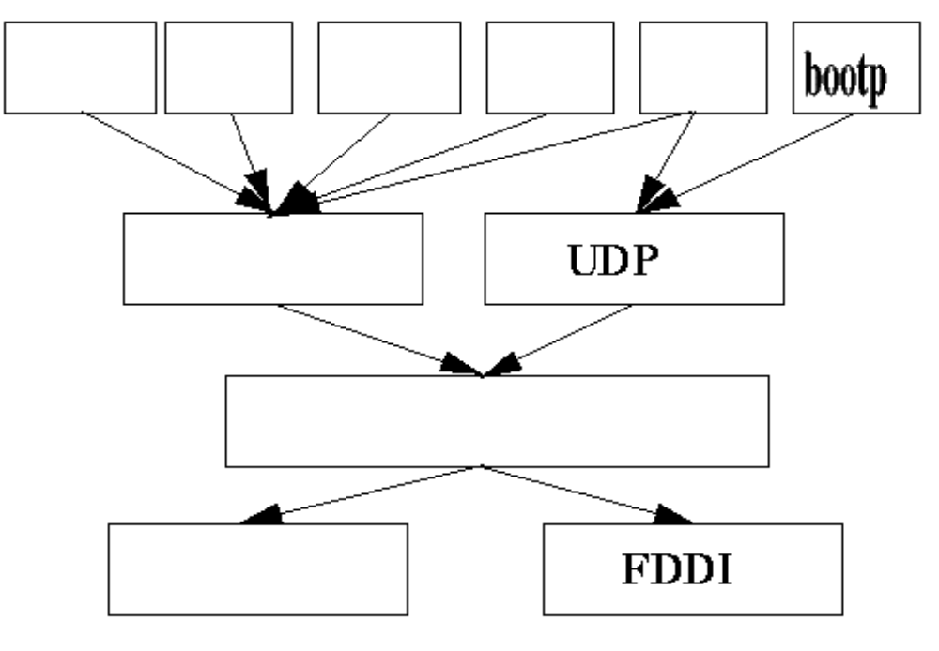
Row 1 (Left to Right): email, ftp, telnet, X11/Wayland/Xwayland/EGLstream, RPC (OSI Level 7)
Row 2: TCP (OSI Level 4)
Row 3: IP (OSI Level 3)
Row 4: Ethernet, FDDI (OSI Level 1)

